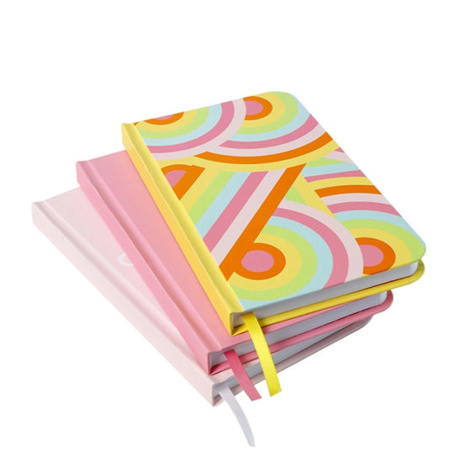

PRINTED DIARIES

RYANA CALENDARS is selling wonderful printed diaries in different colors and designs! It contains different types of designs on its covers!

RS 740